Hi anh Mỹ,

Anh xem giùm em cái testbench em mới tạo lại coi ok ko?

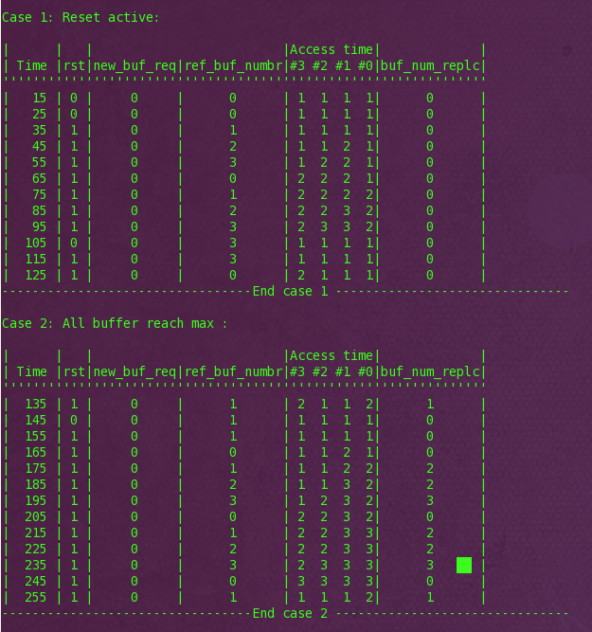

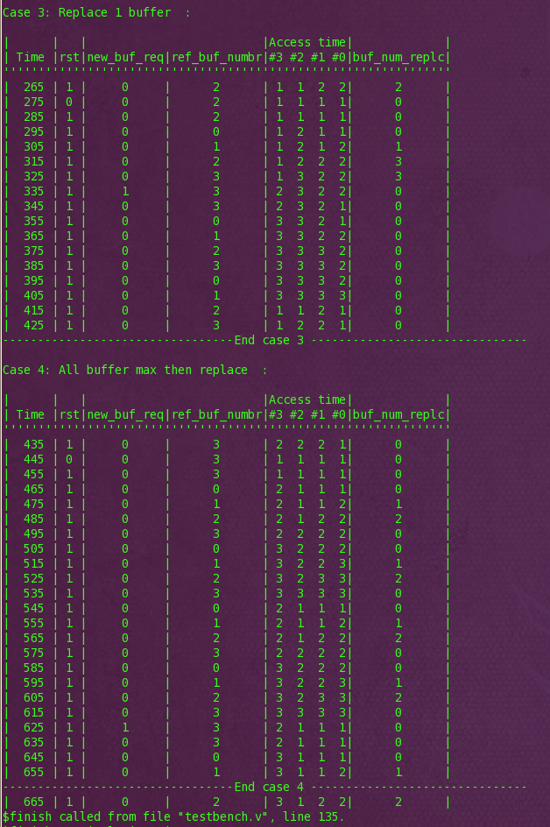

Thanks & Best regards,

An Bui

----------------------------

Bui Huy An

RENESAS DESIGN VIETNAM CO., LTD.

Lot W.29-30-31a, Tan Thuan Road, Tan Thuan EPZ, District 7, HCMC, Vietnam.

Email: [an.bui.nx@rvc.renesas.com](mailto:an.bui.nx@rvc.renesas.com)

**From:** Mỹ Nguyễn (24G) [<mailto:my.nguyen.nx@rvc.renesas.com>]   
**Sent:** Friday, 21 April, 2017 08:24  
**To:** An Huy. Bui <[an.bui.nx@rvc.renesas.com](mailto:an.bui.nx@rvc.renesas.com)>; An Hai Lam. Tran <[an.tran.ra@rvc.renesas.com](mailto:an.tran.ra@rvc.renesas.com)>  
**Subject:** Re: Status Exercise 2

Hi Em, lam nhu vay cung dc nhung hoi kho quan sat, hoi xua anh lam nhu vay, em tham khao nha:  
  
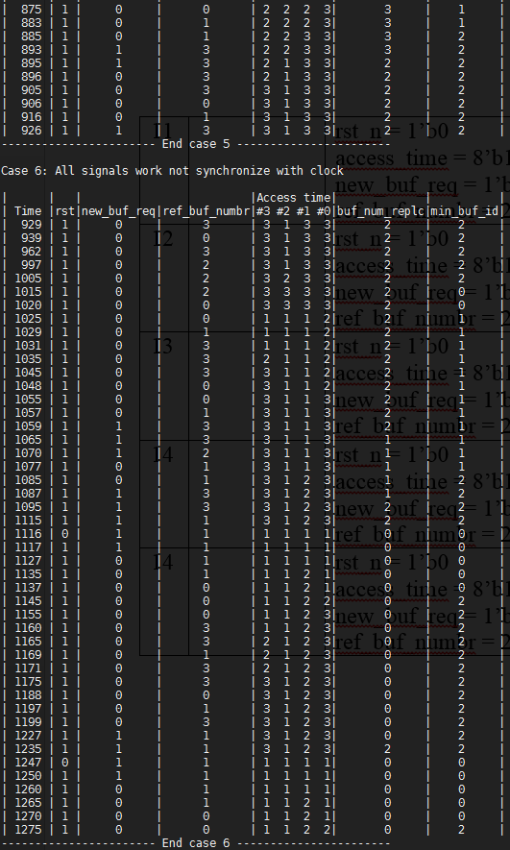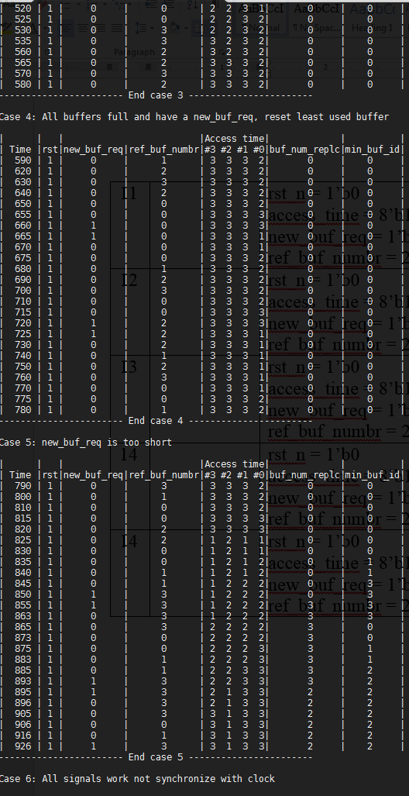  
  
Refer 1 doan code test bench cho tui em tham khao:  
  
*always @( posedge clk )   
begin  
  $strobe("| %4t | %0b |     %2b     |      %1d      | %1d  %1d  %1d  %1d|    %d     |    %3d      |",$time,  
            rst_n,new_buf_req,ref_buf_numbr,  
            lfu_finder_01.access_time[MAX:MAX-1],  
            lfu_finder_01.access_time[MID:MID-1],  
            lfu_finder_01.access_time[LOW:LOW-1],  
            lfu_finder_01.access_time[MIN:MIN-1],  
            lfu_finder_01.min_buf_id,  
            buf_num_replc);    
end  
  
//              Initial reset               //  
//------------------------------------------//  
initial   
begin   
  rst_n = 0 ;  
  # (CYCLE * 3) rst_n = 1'b1 ;  
end  
  
  
//                Function                  //  
//------------------------------------------//  
initial begin  
$display();  
$display ("Case 1: Reset active:");  
$display();  
$display(  "|      |   |                         |Access time|          |             |");  
$display(  "| Time |rst|new_buf_req|ref_buf_numbr|#3 #2 #1 #0|min_buf_id|buf_num_replc|");  
$display(  "'''''''''''''''''''''''''''''''''''''''''''''''''''''''''''''''''''''''''''");  
           ref_buf_numbr = 0;  
           new_buf_req   = 0;  
#(CYCLE)   ref_buf_numbr = 0;  
#(CYCLE)   ref_buf_numbr = 1;  
#(CYCLE)   ref_buf_numbr = 2;  
#(CYCLE)   ref_buf_numbr = 3;  
#(CYCLE)   ref_buf_numbr = 0;  
#(CYCLE)   ref_buf_numbr = 1;  
#(CYCLE)   ref_buf_numbr = 2;  
#(CYCLE)   ref_buf_numbr = 3;  
#(CYCLE)   rst_n = 0;  
#(CYCLE)   rst_n = 1;  
#(CYCLE)   ref_buf_numbr = 0;  
#(CYCLE)   ref_buf_numbr = 1;  
#(CYCLE)   ref_buf_numbr = 2;  
#(CYCLE)   ref_buf_numbr = 3;  
#(CYCLE)   ref_buf_numbr = 0;  
#(CYCLE)   ref_buf_numbr = 1;  
#(CYCLE)   ref_buf_numbr = 2;  
#(CYCLE)   ref_buf_numbr = 3;  
  
$display ("--------------------------------- End case 1 ------------------------------");  
$display();*

On 4/21/2017 8:19 AM, An Huy. Bui wrote:

Hi anh Mỹ,

Lát e up code với testbench lên redmine. H e gửi kết quả testbench cho anh coi trước nha.

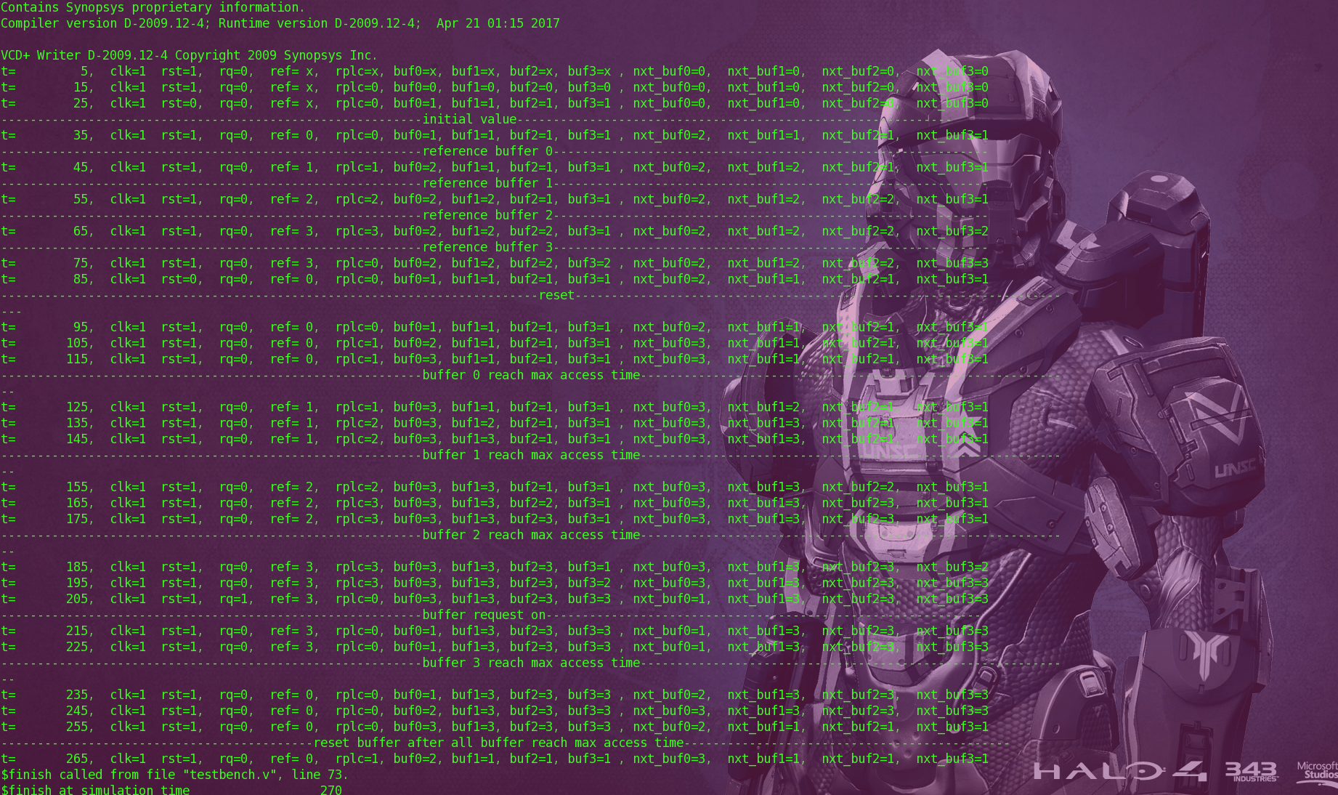

Thanks & Best regards,

An Bui